

Name: PREMAHLATHA D/O RAMASAMY

Login ID: premahlatha@oasis-portal.com

Course title: ESSENTIALS OF MARKETING AND CUSTOMER

RELATIONSHIP

Subject Code: BHM02

Submitted date: 24 JULY 2017

**Table of Contents**

|  |  |  |
| --- | --- | --- |
| No | Details | Page |
| 1 | Executive Summary | 2 |
| 2 | Introduction | 3-4 |
| 3 | Assignment Question |  |
|  | Part 1 | 5 |
|  | Part 2 | 6-7 |
|  | Part 3 | 8-9 |
|  | Part 4 | 10-11 |
| 4 | Conclusion | 12 |
| 5 | References | 13-14 |
|  | Appendix | 15 |

**Executive Summary**

In this assignment, I’m able to acknowledge the relationship between marketing and customer service within a Hospitality Management Operation. Marketing is a way to promote or publicize a product to a potential customer which will make them satisfy with that product. The three-main element in this business is marketer, product and target market.

First, I explained about what are the concepts of Marketing in Hospitality and the important of marketing in Hospitality Management.

Next, I’m able to differentiate the marketing and customer service in Hospitality Management and explained about the ethics of both operations which is essential in hospitality industry.

Furthermore, the description about Marketing strategies (7p’s) and the key points of those strategies are given in this part.

Finally, the details of customer service skills and its characteristics in hospitality management are explained in this section. And I’m also able to describe the contribution of customer service in hospitality management.

**Introduction**

There is no ending for satisfaction because it’s human’s nature where always go behind of the new inventions. Despite, how to bring the latest invention to people’s perspective? Here the marketing plays its part to promote the inventions. Marketing is the process consists of more than one person and the 3-main element in this process is marketer, what is being marketed, and target market (customer). We can also understand marketing as a process to make money where the exchange of product is carry out by a marketer to get money from an individual.



The term ‘marketing’ comes from the word market; a Latin word “Marcatus” which means ‘a place where business is carry out by people which involves the both process of buying and selling’. Comparing to barter; a system of exchanging goods and service without money, marketing is more consistent. The advantage of marketing is business promotion. When we promote a new product in a market, we will get the attention of the target customer because it’s the only way where to share what product we have and may know what are the customer’s need. And, no one will get to know what product that we have until we promote it in front of people. When the product gets exchanged or going hand-to-hand between customer, our brand will easily and early will recognized by customer. Over time people will start to associate our logo and brand with our own business. What will happen if our product gets a good response after marketing? It’s sure that our business profit will increase and the goal “spend money for make more money” can be achieved.

If marketing happens, there is a bond form called customer relationship. The development of an ongoing connection between a company and its customers is called customer relationship. The relationship involves marketing communications, sales support, technical assistance and customer service. The relationship is measured by the degree of customer satisfaction through the buying cycle and following receipt of goods or services. The Customer Relationship Management (CRM) uses its business strategies to attract more customers. Furthermore, by collecting the feedbacks and comment from customers, this management able to manage and put efforts to make changes to the industries because these changes may make the regular and new customers satisfy. A company’s victory not only about the profit earned but is also known for its pride and the customers who come to visit regularly.

Both marketing and customer service is essential part in hospitality. The reasons why this both units need to work together is for better social media support. Marketers mostly using social media to provide customer service because they have likely been given the proper training and resources needed to assist customers and resolve issues, meaning they are the best people for the job. Next, for a deeper understanding of buyer’s personas which mostly customer service team spend their all-time in talking to customers, meaning they probably know more about them than any other department within a company. So, because understanding buyer’s personas is so critical, marketers to work more closely with customer service to help them truly understand customers’ needs and thoughts. And, for setting customer expectation an effective marketing team need to have clear expectation for how business product and services will help them. For prevent customer loss, marketing team need to know customer’s needs and then only the relationship between customer can go much smoothly. Here the customer service team will help by notice and correcting mistakes and misleading expectation. Therefore, they need to create a relationship where should go together like milk and cookies while most marketers admit that customer service is a major function of their social presence.

**Assignment Questions**

**Question 1**

Briefly explain about Marketing in Hospitality and the importance of Hospitality Marketing. (20 Marks)

A marketing is a concept which is essential in all industries including hospitality. This concept is driven from customer’s demand which is related to the flow of goods and services from producers to consumers. According to Chigozie (2007), marketing is not just finding the alternative routes to promote the products and services. To him, it’s an art of identifying and understanding about what are the customer’s needs and creating solution to deliver it to the customer and make profit to the related peoples such as retailer, salesman, advertising agents, etc. Making profits will make the business grow faster.

When it starts to mention hospitality, we know that it’s fully about visitors, travelers and tourist. The businesses involve with hotels are accommodation, foods, recreational centers for visitors, catering services and social function services where needs extra responsibility. So, the main concept is makes the guest happy, comfortable and satisfy with the services given at hotels. The best way to promote the services is by marketing. Past days, due to of lack of technology the customers unable to know about the price, promotions, place and product of the hotels. Nowadays, the improvement in technology and updates of studies about hospitality helps the marketers in promoting the products by direct approach and social media.

Marketing in Hospitality basically different from other industries because for others they need third party to promote their products, and in hospitality, the people in hospitality line need to face-to-face with customer directly. For an example, in health industries they indirectly meet up with their customer or consumer. They need the third party a pharmacy or health care to promote their new product such as vitamin, supplement, etc. Even they made profit, they still lack with customer’s direct approach and unable to guess what are the next expectation of customers and their feedback on the previous product. But in hospitality, each person will directly mingle with guest where a door boy also gets a chance to give a warm welcome to the guest. All staff will get a time to talk or give opinion on what product they are going to promote or on sales now.

The importance of Hospitality Marketing is the marketers can identify what factors make customers choose a hospitality service and this requires extensive research. For example, the marketers can collect the data by speaking to current or former guest, monitoring customer reviews on websites, reviewing industry data and learns what makes other hospitality service stand out. Next, marketers want to make sure that all the information on hotels, resorts and restaurant are easily find and up-to-date by customers. Buying ad space on relevant travel sites, creating websites on hotel and collaborating with noncompeting hospitality services in the same market are some of the ways where marketers aware of customer. Running promotion during certain times of years mostly when business is slower is also an important. Other important of marketing is to have a good customer relationship to ensure high levels of repeat business where reward the regular customer who usually uses the same hospitality service.

**Question 2**

Explain the differences between Marketing VS. Customer Service.

Explain the Ethics of Marketing and Customer Service. (20 Marks)

|  |  |
| --- | --- |
| Marketing | Customer Service |
| Drawing attention, generating leads, and making sales | Reducing confusion, troubleshooting product or service problem, and resolving issues with unsatisfied customer |
| Define business by benefits for customer | Define business by goods and service |
| Mostly aim a specific group of customers | Everybody |
| Involve getting the customer to the product | Involve getting the service to the customer |

Marketing will get attention from customer for their promoting and at the end they will make sales. We can define their business by benefits for customer because their main aim is always a specific group of customers who will buy the product and become consumer. Simply to tell, marketing involves getting the customer to the product.

The customer service is for reducing confusion, troubleshooting product or service problem, and resolving issues with unsatisfied customer. This business can define by goods and service to the customer at right time and not only for regular customer; to every single visitor or traveler. This part involves getting the service to the customer.

What are the ethics of marketing and customer service? It is an area of applied ethics which deals with the moral principles behind the operation and regulation of marketing and customer service. Some areas of marketing ethics overlap with media ethics.

The marketing ethics consists of:

* Marketing effectiveness
* Market research
* Market segmentation
* Marketing strategy
* Marketing management
* Market dominance

The ethical code is the principles governing morality and acceptable behaviors which covers personal behavior, environmental behavior, corporate behavior and societal behavior.

The customer service ethics consist of:

* Utilitarian approach
* Rights approach
* Fairness approach
* Virtues approach
* Common good approach

This customer service ethics are very important help in determining the right course of action and to analyze if decisions or reaction are correct for a particular setting.

**Question 3**

Describe about Marketing strategies and how you can apply your studies in Hospitality

Management. (20 Marks)

The marketing strategies are the important aspects in hospitality that should always have updates depends on changes in that industries. The aspects are product, price, place, promotion, people, process and physical evidence.

**Product**

A product is something that manufacture from an industry and sold in market. In term of hospitality, the product is the services, foods and rooms. The product not only made for fulfill the customers’ needs but also must have a good quality because the higher the quality the higher the demand for the product. If the product start to get a good response from consumers than the marketers just need to update some changes to the product, but at first, they must try to attract the customer due to customers always won’t touch or start to use new products and they always prefer the old product. Variant creations or create more choices in hospitality like rooms for different status peoples and available in more than 2 places will be convenient to the customers. For increase the number of customers, the hospitality management must give warranty for product and assurance for services.

**Price**

When we start to promote a product the first thing that comes to customers mind is price. If a room price is above 500$ the customers start to bargain to decrease the price. So, the priority is given to price for a target product because all people always prefer to the lowest price. Discount, half price, cash discount and stock clearance are included in price. Nowadays the upgrades in technology make peoples pay their payment via credit card or installment. These upgrades are very useful in hospitality where they (customers) can pay their room booking charges in cash, bank transfer, e-pay, credit/debit and PayPal (ATM).

**Place**

Usually a place is an area in a space. But the worth for the location is depending on the surrounding environment. The hospitality management should have a clear picture of the development of the industry because after build a hotel at a urban area or remote area and no business is take place, the lost cannot exchange with nothing. The place that choose should be very convenient for customers. This is due to, especially about price people won’t try to take risks and they will gather information about the industry’s development and then only they will start to take next step. Having many branches will make easier for customers to find a suitable and comfortable hotel for them.

**Promotion**

This is a unique aspect where a hotels’ name will review by the society for its new updates and publicity. For an example, a hotel starts to give promotion on room pricing like reduction in old price will directly attract viewers to get more information on its promotion. Marketing communication where all runs in social media will be very helpful for the marketers and the whole hospitality industry. It is much better idea compare to give the same explanation to the coming customers by hospitality management where by click a button new news can spread within a second.

**People**

People are the main profit for all firms because without them no sales and no profit can earn by the firm. The peoples involve in the hospitality environment such as recruiter, customer, supplier, marketer, customer service team and so on are also peoples who contribute to the development of the firm. The strong relationship between all department people within a company will give success by exchanging their ideas on improving firm’s products and services.

**Process**

Sequence of interdependent and linked procedures which, at every stage, consume one or more resources (employee time, energy, machines, money) to convert inputs (data, material, parts, etc.) into outputs. These outputs then serve as inputs for the next stage until a known goal or result is reached. This aspect is much more focus on customers’ needs and processing on what product the customer wants and need. With having the IT-support designing or program the new products will make more interesting and customers will easily attract by it.

**Physical Evidence**

Every firm will always have their own name cards where its occupied with sales and staffs contact. This physical evidence is easier to customer to find us in easy way. Providing the firm’s online pages to customer also make both parties work less because online business is always save time, money and energy.

**Question 4**

Explain in detail on Customer Service Skills and Characteristics.

Explain the Importance of Hospitality Customer Service. (20 Marks)

If mention customer service, should have some positive skills and without that skills a staff cannot be in a complete customer service team.

The skills are:

**Patience:**

The staff should make sure to stay patient when customer comes stumped and frustrated. They also must take time to truly figure out what they want by spending time with customer to better understand their problems and needs from the company.

**Clear communication skills**

Staffs must always keep it simple and short and leave nothing to doubt when it comes to important points that need to relay clearly to customers.

**Knowledge of the product**

Not only customer service team but every staffs should be able to know the ins and outs of how product works because without knowing the product from front-to-back, hospitality management won’t know on help customer when they run into problems.

**Ability to use positive language**

The ability to make minor changes in the conversational pattern with customer can truly go a long way in creating happy customers. Language is important because customer will create perceptions about staffs and company based off the language that the staffs use.

**Time management skills**

The customer service team members must try to spend time with customers to be concerned with getting customers what they want in an efficient manner. If cannot solve a problem of the customer, let other support member to get the customer and don’t ever waste the time by trying to go above and beyond the customer.

Why this customer service is so important in hospitality?

Customer expectation- A satisfied customers are looking for a memorable experience and an energetic service, where it matters the most. In hospitality, be aware that it’s becoming ever more popular for guests to leave a review of their experience on many feedback sites, whether bad or good one. Try to avoid the customer to give a negative feedback.

Deliver on promise- Always deliver what was promised for the customer, if possible try to exceed the expectation where possible to help gain referrals.

Customer loyalty- Customers are most important part of the business. So, make customer happy and they will be the loyal customer. Try to provide additional care and service where possible and this always tends to impress.

Feedback is important- If a customer have a bad experience, make sure the customer service team clear for them and allow the customer to get it off their chest towards staff, so they’re not inclined to tell someone else. Always try hard to fix the problem using communication as a key and make customer ultimately goes away happy.

**Conclusion**

So, if a market plan and customer relationship in Hospitality Management failure, the firm will go on development of the market instead of not retreating by failure. The company should develop a new marketing strategy for progress of the market, with objectives of studying of new areas for trading in products. The alternate plan of the company will make 10% from marketing plan. Strategy formulation must therefore be regarded as a procedure of constant learning, which includes knowledge about the goals of hospitality, the consequences of potential procedures towards these goals and how to execute and accomplish these actions.

**References**

1. Wikipedia (2017) (Online) What is Marketing?

Retrieved from:

<https://en.wikipedia.org/wiki/Marketing>.

1. The Company Warehouse (2014) (Online) Advantage of Marketing- Introduction

Retrieved from:

<https://www.thecompanywarehouse.co.uk/blog/advantages-and-disadvantages-of-marketing>

1. Business dictionary (Online) What is Customer Relationship?

Retrieved from:

<http://www.businessdictionary.com/definition/customer-relationship.html>

1. HubSpot (April 23, 2012) (Online) by [Pamela Vaughan](https://blog.hubspot.com/marketing/author/pamela-vaughan)| @[pamelump](https://twitter.com/pamelump" \t "_blank) Reasons Why Marketers and Customer Service Should Work Together?

Retrieved from:

<https://blog.hubspot.com/blog/tabid/6307/bid/32478/7-Reasons-Marketing-Customer-Service-Need-to-Work-Together.aspx>

1. Business Dictionary (Online) Meaning of Product.

Retrieved from:

<http://www.businessdictionary.com/definition/product.html>

1. Business Dictionary (Online) Meaning of Price.

Retrieved from:

<http://www.businessdictionary.com/definition/price.html>

1. Business Dictionary (Online) Meaning of Promotion.

Retrieved from:

<http://www.businessdictionary.com/definition/promotion.html>

1. Business Dictionary (Online) Meaning of Process.

Retrieved from:

<http://www.businessdictionary.com/definition/process.html>

1. Business Life (2013) (Online) Importance of Customer Service in Hospitality.

Retrieved from:

<http://www.northwestbusinesslife.co.uk/news-item/the-importance-of-customer-service-in-the-hospitality-industry/>

1. Help Scout (2016) (Online) Customer Service Skills.

Retrieved from:

<https://www.helpscout.net/blog/customer-service-skills/>

1. Slide Share (2016) (Online) Ethics of Customer Service.

Retrieved from:

<https://www.helpscout.net/blog/customer-service-skills/>

1. Concordia (2016) (Online) the Importance of Marketing in Hospitality.

Retrieved from:

<https://online.csp.edu/blog/business/the-importance-of-marketing-in-the-hospitality-industry>

**Appendix**

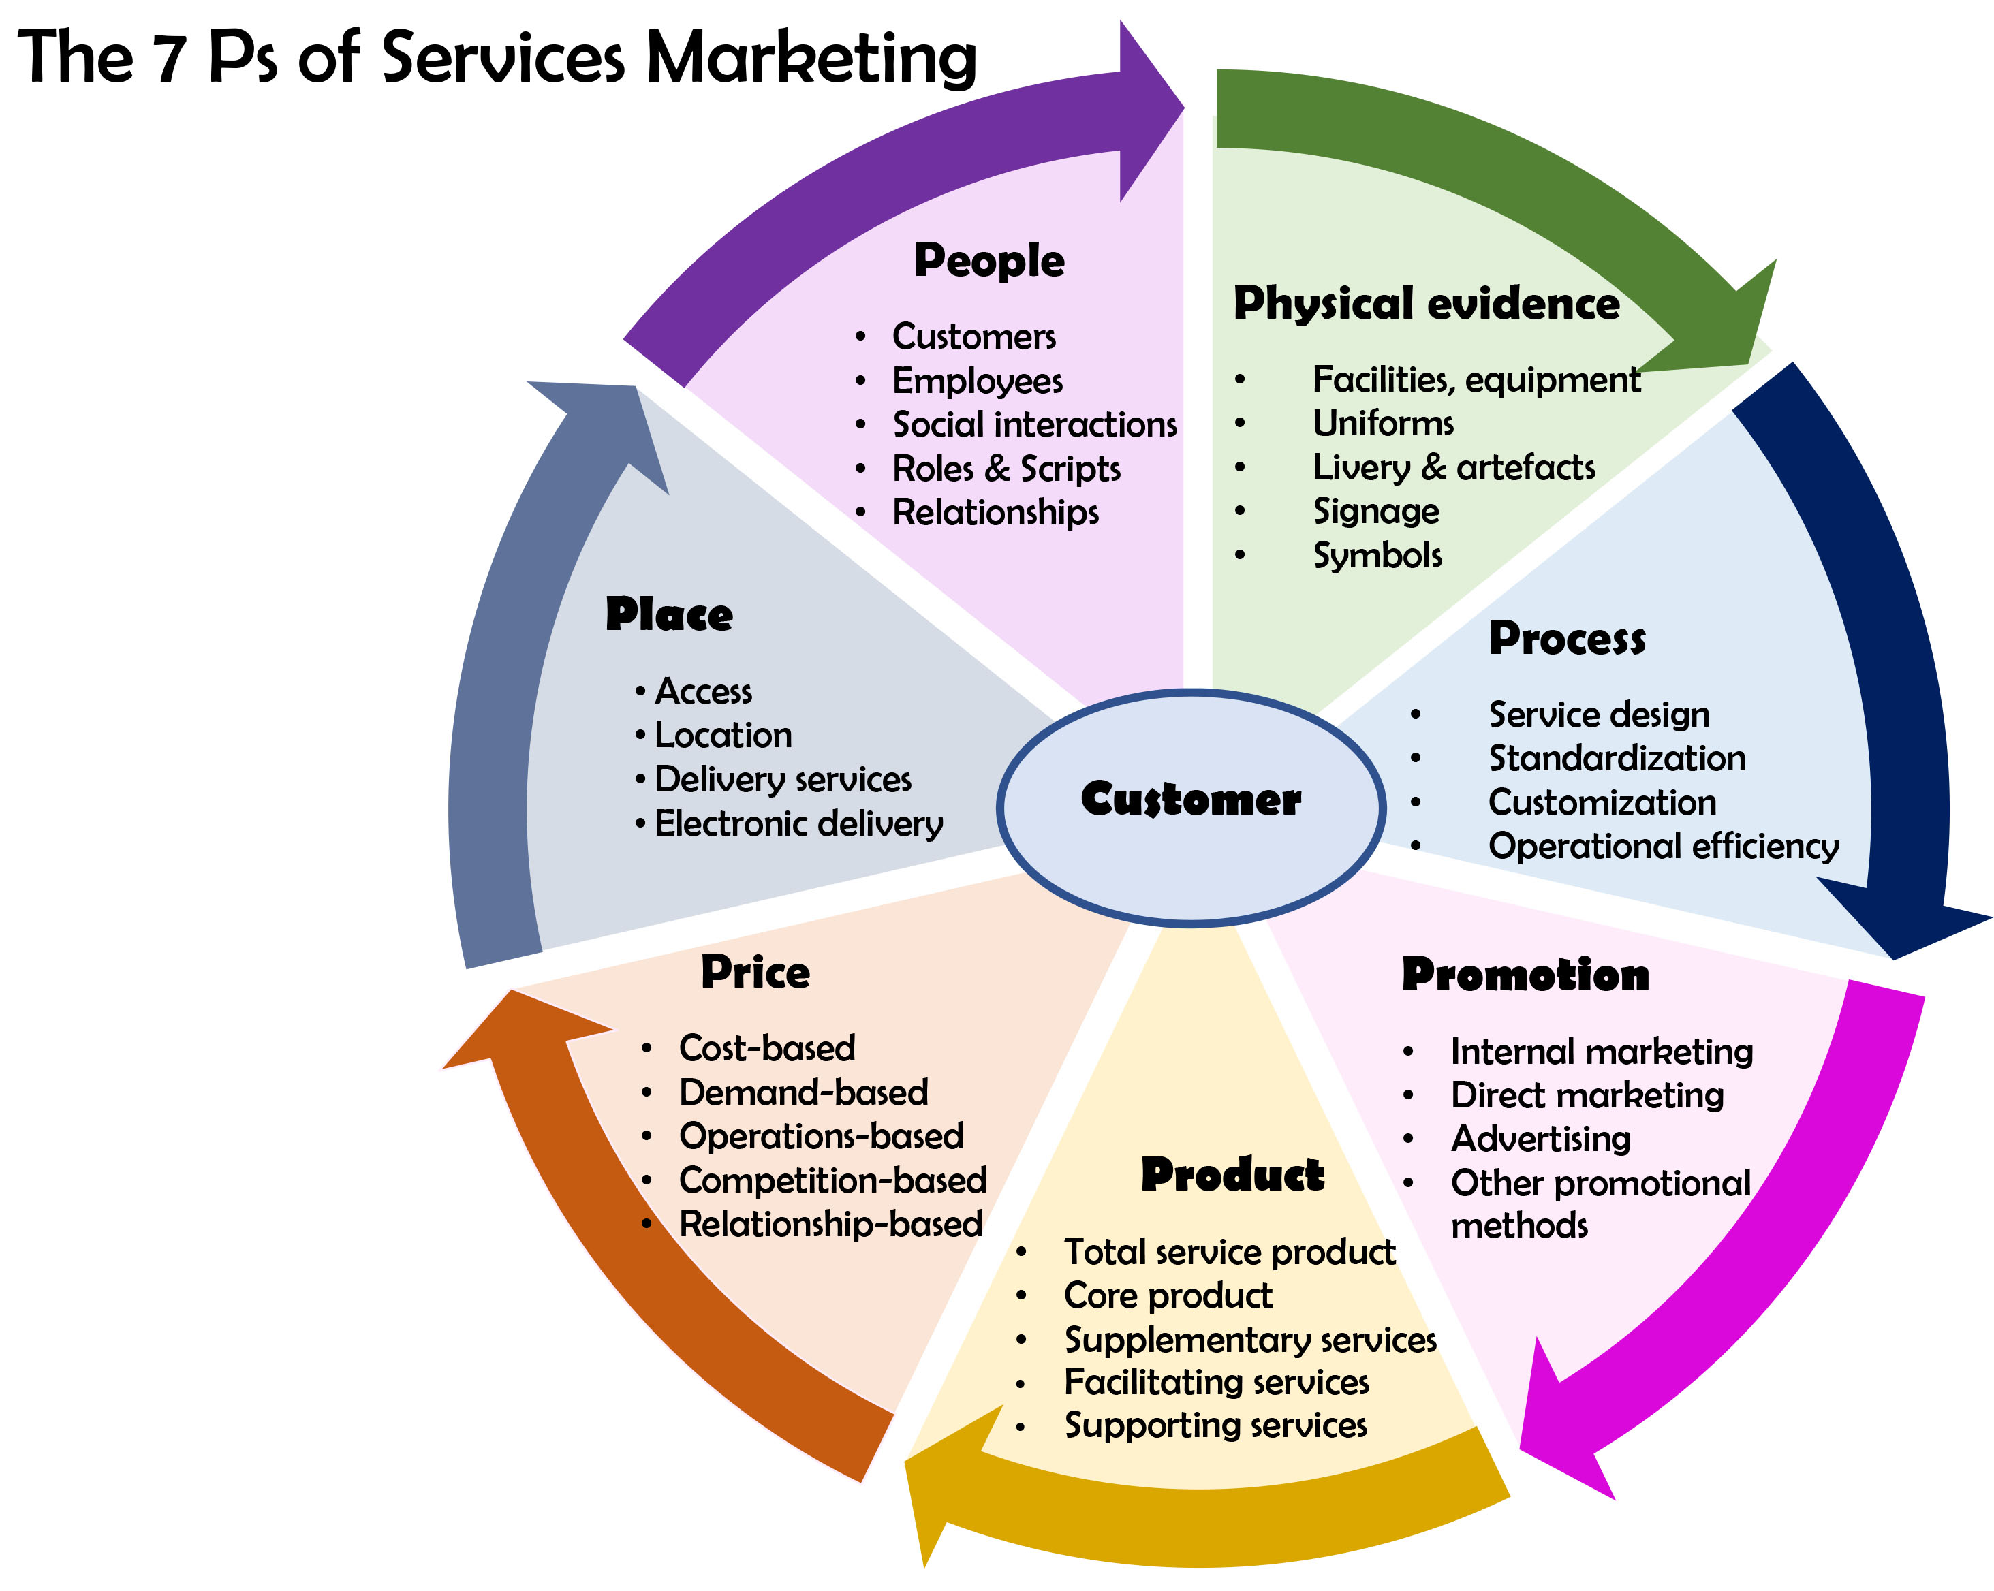

The Customer Relationship Management (CRM)

